**Week 1 – Adhiraj Bhagawati**

Found a dataset- tried to debunk it.

* <http://cdsportal.u-strasbg.fr/?target=HD%20226868>
  + Find out what “Main ID” column represents
  + Plot Luminosity vs arcsec
  + SEARCH FOR MORE DATASETS

Found out that the dataset can’t be used, since it’s not specifically about Cygnus X1.

Nevertheless, did simple Exploratory Data Analysis on the data.

Results:

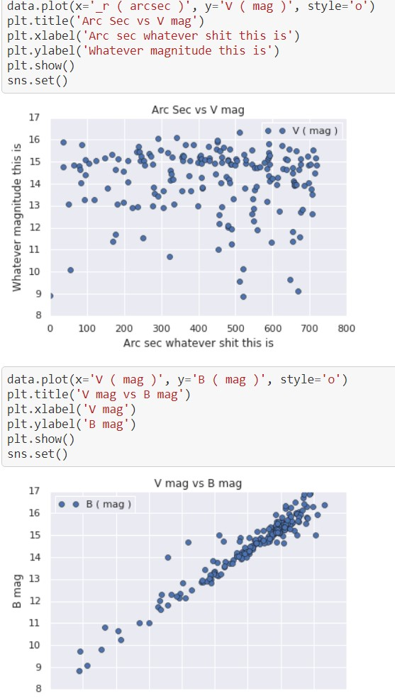

Used data from the research paper:

[**https://iopscience.iop.org/article/10.1088/0004-637X/701/2/1895/pdf**](https://iopscience.iop.org/article/10.1088/0004-637X/701/2/1895/pdf)

and tried to correlate data with theory from this paper:

# [**https://academic.oup.com/mnrasl/article/440/1/L61/1391298**](https://academic.oup.com/mnrasl/article/440/1/L61/1391298)

and proved mass-luminosity relation for HD226868.

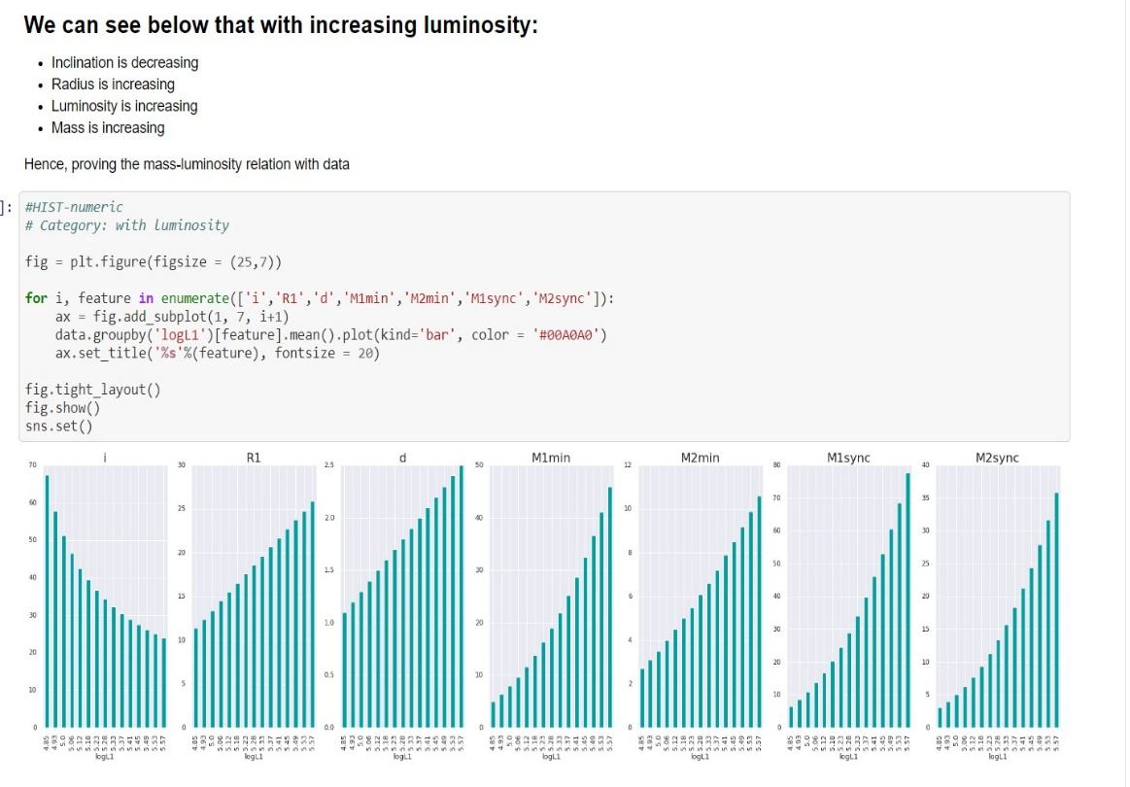

At last with the same data, I also predicted the M1min values of HD226868 with increasing distance based on data with linear regression.

Accuracy:

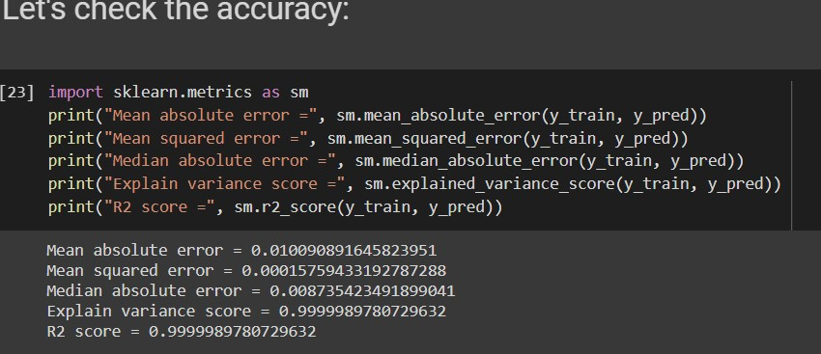

And predicted mass:

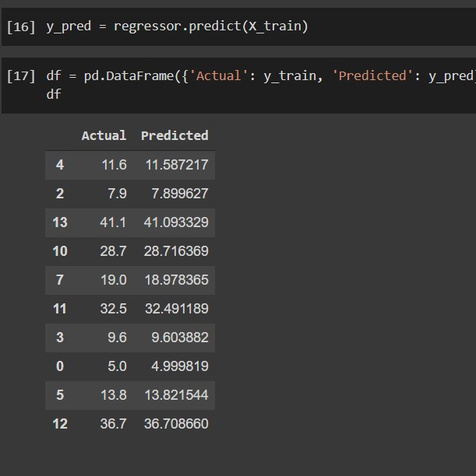

Also, after yesterday’s meeting, we found a library for python to simulate some stuff called einsteinPy.

Since mass of Cygnus X1 is 14-16 solar mass (in Wikipedia)

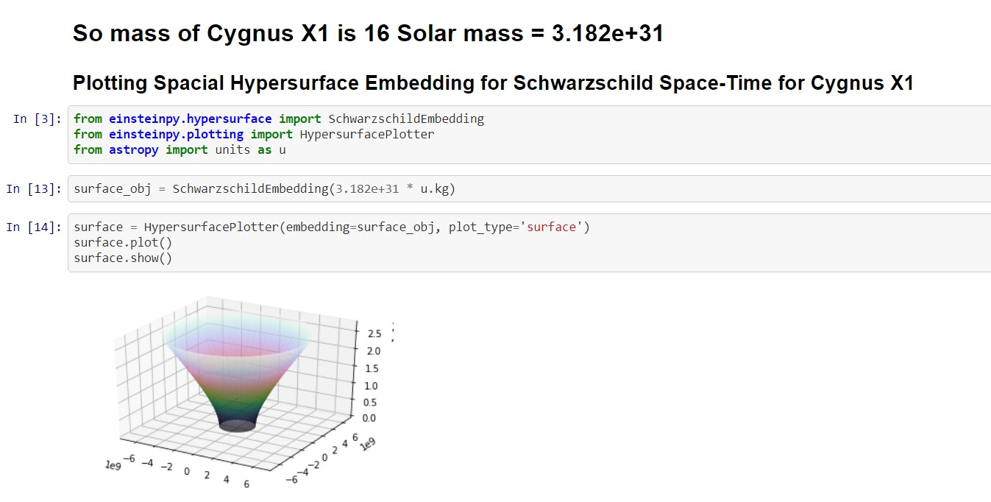

Also, regarding Unity:

A black hole shader; as it is performed by ray tracing, it conforms to the actual appearance of the black hole. The shader also considers the gravity redshift effect which is in theory caused by the differences of gravitational force between the observer and the light source.

(For generating accretion disk)

Redshift texture is a lookup texture for gravitational redshift. The horizontal axis is 3a / R, and the vertical axis is a / r0. Where R, r0 are the position (radius) of the light source and the position (radius) of the observer.

I used data from <http://cvrl.ucl.ac.uk/cmfs.htm> and downloaded a csv file.

Then exported textures from a python notebook for temperature and now I have made a good-looking black hole for now:

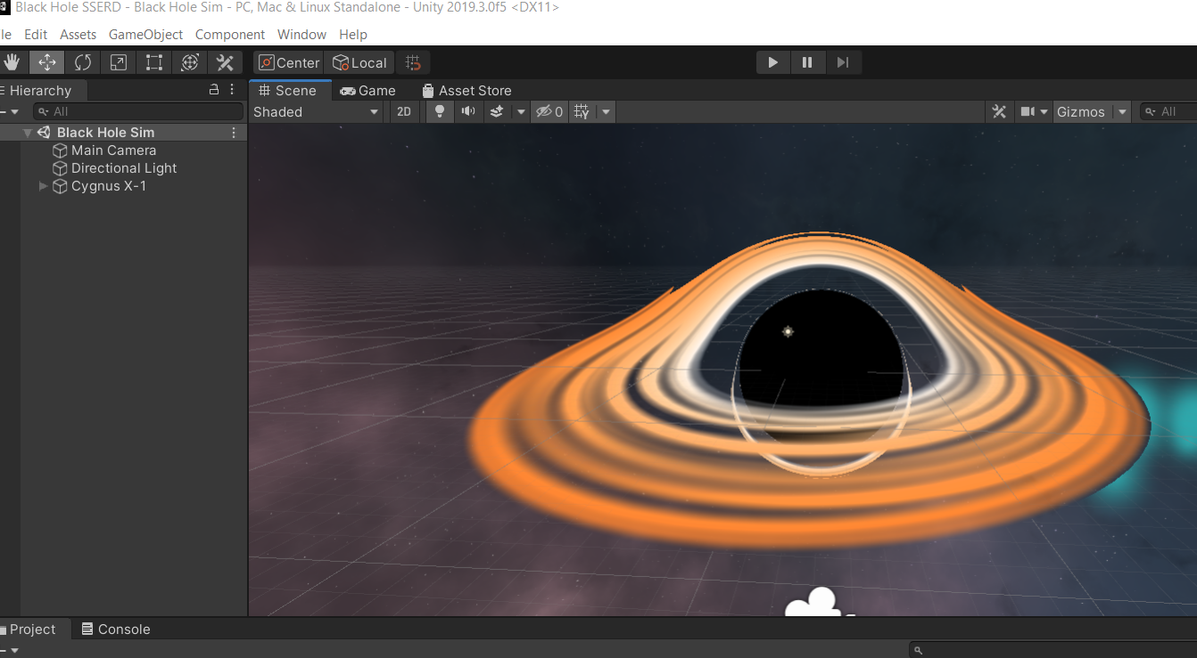

With the textures used from the redshift.ipynb